Ejabberd sobre “AWS ECS on EC2”
AYUDA GENÉRICA How to move the office to real time IM on ejabberd | ProcessOne

Pasos
Pasos
- Crear VPC ...
- Crear un cluster (OJO!: Old ECS experience) , registrar una tarea y lanzar una instancia de contenedor en AWS ECS sobre EC2 Getting started with the console using Amazon EC2 - Amazon Elastic Container Service (Ojo al firewall, el security group (sg) debe permitir en entrada los puertos SSH más los del servicio de mensajería y en salida llegar a todos los puertos y todo internet)
- Crear instancia EC2 para ECS.
- Asignar rol Labrolinstance
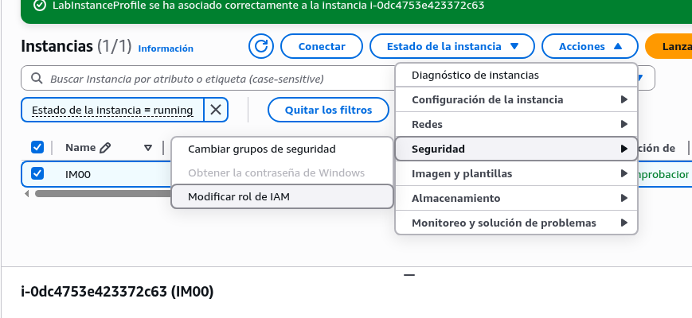
- Registrar instancia en el cluster.
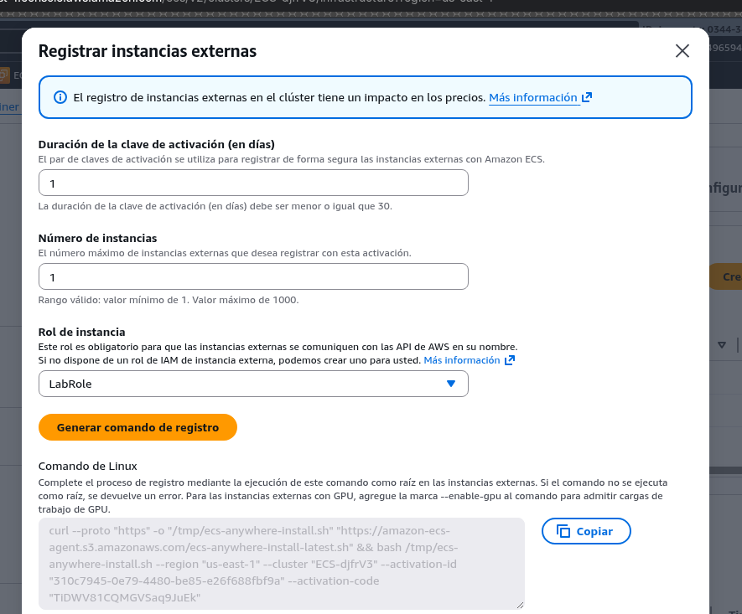
- Crear la definición de la tarea. (JSON en páginas siguientes)
- Crear el servicio para desplegar dicha tarea.
- Crear los puntos de montajes en la instancia (ojo a los permisos y propietarios 9000:9000) y poner la configuración del servidor IM en su archivo ejabberd.yml (Ver al final del documento adaptándolo a tu dominio)
- Asociar tu nombre de dominio imXX.institutodh.net a la IP de tu instancia.
- (Opcional) Forzar un nuevo despliegue del servicio.
- Crear el usuario admin (si no lo has hecho ya en el JSON)
docker exec ecs-ejabberd-4-ejarbberd-ct-f087d5d1d6e9df8dff01 \
ejabberdctl register admin im.institutodh.net passw0rd.!

- Instalar certbot, obtener el certificado, ponerlo en database/certs e incluirlo en el yml. Re-desplegar.
- Conectarse a la consola Web (http://dominio:5443/admin) y a continuación... Crear otros usuarios, grupo por defecto, y salas de chat públicas y privadas, por comando o por la web Next Steps - ejabberd Docs
docker exec ecs-ejabberd-4-ejarbberd-ct-f087d5d1d6e9df8dff01 \
ejabberdctl create_room open conference.im.institutodh.net im.institutodh.net # crea una sala de charla publica open@conference.institutodh.net
docker exec ecs-ejabberd-4-ejarbberd-ct-f087d5d1d6e9df8dff01 \
ejabberdctl change_room_option open conference.im.institutodh.net persistent true # hace a la sala persistente
docker exec ecs-ejabberd-4-ejarbberd-ct-f087d5d1d6e9df8dff01 \
ejabberdctl change_room_option open conference.im.institutodh.net title "Charla abierta" # assigns a room title

- Instalar un cliente de XMPP y conectarse al servidor para chatear con otros usuarios y entrar en la sala pública.

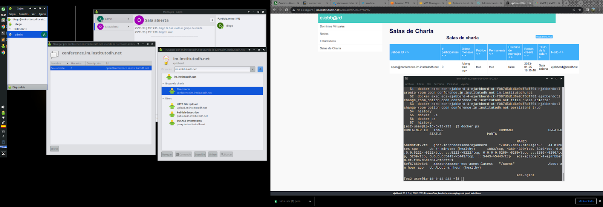

Acceder desde PC en casa a http://imXX.institutodh.net:5200/admin
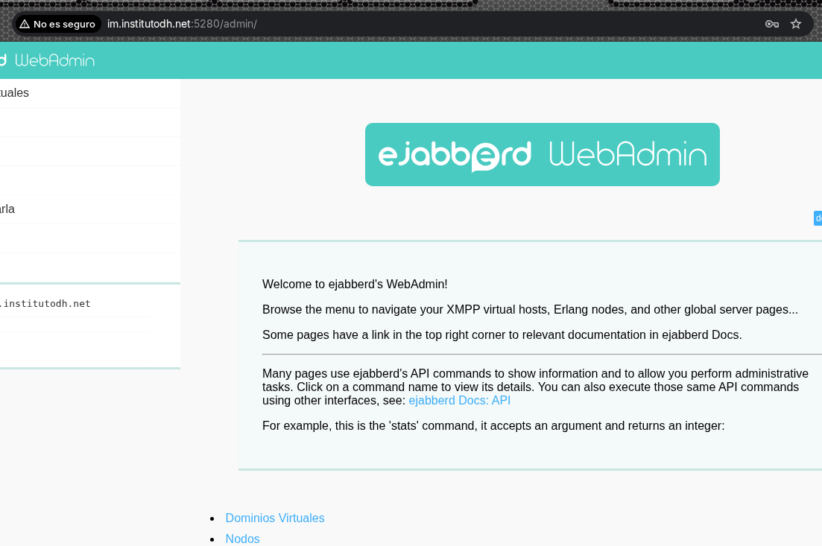

Administrar el servicio....
JSON para tarea ejabberd 2025 AWS ECS sobre EC2
{ "compatibilities": [ "EC2" ], "containerDefinitions": [ { "cpu": 0, "dnsSearchDomains": [ "institutodh.net" ], "dnsServers": [ "1.1.1.1" ], "environment": [ { "name": "CTL_ON_CREATE", "value": "register admin im.institutodh.net usuario" } ], "essential": true, "hostname": "im", "image": "ghcr.io/processone/ejabberd", "logConfiguration": { "logDriver": "awslogs", "options": { "awslogs-group": "/ecs/ejabberd-v1", "awslogs-create-group": "true", "awslogs-region": "us-east-1", "awslogs-stream-prefix": "ecs" } }, "mountPoints": [ { "containerPath": "/opt/ejabberd/conf/ejabberd.yml", "readOnly": false, "sourceVolume": "yml" }, { "containerPath": "/opt/ejabberd/database", "readOnly": false, "sourceVolume": "database" } ], "name": "ejabberd-ct", "portMappings": [ { "appProtocol": "http", "containerPort": 5280, "hostPort": 5280, "name": "bosh", "protocol": "tcp" }, { "containerPort": 5222, "hostPort": 5222, "name": "xmpp", "protocol": "tcp" }, { "containerPort": 5443, "hostPort": 5443, "name": "https5", "protocol": "tcp" } ], "systemControls": [], "volumesFrom": [] } ], "cpu": "1600", "enableFaultInjection": false, "executionRoleArn": "arn:aws:iam::034434236872:role/LabRole", "family": "ejabberd-v1", "memory": "1600", "networkMode": "bridge", "placementConstraints": [], "registeredAt": "2025-12-12T12:34:02.593Z", "registeredBy": "arn:aws:sts::034434236872:assumed-role/voclabs/user4496594=_Student_View__Diego_Jes__s_Fern__ndez_Raposo", "requiresAttributes": [ { "name": "com.amazonaws.ecs.capability.logging-driver.awslogs" }, { "name": "ecs.capability.execution-role-awslogs" }, { "name": "com.amazonaws.ecs.capability.docker-remote-api.1.19" }, { "name": "com.amazonaws.ecs.capability.docker-remote-api.1.17" }, { "name": "com.amazonaws.ecs.capability.task-iam-role" }, { "name": "com.amazonaws.ecs.capability.docker-remote-api.1.29" } ], "requiresCompatibilities": [ "EC2" ], "revision": 6, "runtimePlatform": { "cpuArchitecture": "X86_64", "operatingSystemFamily": "LINUX" }, "status": "ACTIVE", "taskDefinitionArn": "arn:aws:ecs:us-east-1:034434236872:task-definition/ejabberd-v1:6", "taskRoleArn": "arn:aws:iam::034434236872:role/LabRole", "volumes": [ { "host": { "sourcePath": "/home/ubuntu/ejabberd.yml" }, "name": "yml" }, { "host": { "sourcePath": "/home/ubuntu/database" }, "name": "database" } ], "tags": [] }

{
"family": "ejabberd-v1",
"containerDefinitions": [
{
"cpu": 0,
"dnsSearchDomains": [
"institutodh.net"
],
"dnsServers": [
"1.1.1.1"
],
"environment": [
{
"name": "CTL_ON_CREATE",
"value": "register admin im.institutodh.net usuario"
}
],
"essential": true,
"hostname": "im",
"image": "ghcr.io/processone/ejabberd",
"logConfiguration": {
"logDriver": "awslogs",
"options": {
"awslogs-group": "/ecs/ejabberd-v1",
"awslogs-create-group": "true",
"awslogs-region": "us-east-1",
"awslogs-stream-prefix": "ecs"
}
},
"mountPoints": [
{
"containerPath": "/opt/ejabberd/conf/ejabberd.yml",
"readOnly": false,
"sourceVolume": "yml"
},
{
"containerPath": "/opt/ejabberd/database",
"readOnly": false,
"sourceVolume": "database"
}
],
"name": "ejabberd-ct",
"portMappings": [
{
"appProtocol": "http",
"containerPort": 5280,
"hostPort": 5280,
"name": "bosh",
"protocol": "tcp"
},
{
"containerPort": 5222,
"hostPort": 5222,
"name": "xmpp",
"protocol": "tcp"
},
{
"containerPort": 5443,
"hostPort": 5443,
"name": "https5",
"protocol": "tcp"
}
],
"systemControls": [],
"volumesFrom": []
}
],
"taskRoleArn": "arn:aws:iam::034434236872:role/LabRole",
"executionRoleArn": "arn:aws:iam::034434236872:role/LabRole",
"networkMode": "bridge",
"volumes": [
{
"host": {
"sourcePath": "/home/ubuntu/ejabberd.yml"
},
"name": "yml"
},
{
"host": {
"sourcePath": "/home/ubuntu/database"
},
"name": "database"
}
],
"placementConstraints": [],
"requiresCompatibilities": [
"EC2"
],
"cpu": "1600",
"memory": "1600",
"runtimePlatform": {
"cpuArchitecture": "X86_64",
"operatingSystemFamily": "LINUX"
},
"enableFaultInjection": false

Fichero de configuración del servicio ejabberd
ejabberd.yml
###
### ejabberd configuration file
###
### The parameters used in this configuration file are explained at
###
### https://docs.ejabberd.im/admin/configuration
###
### The configuration file is written in YAML.
### *******************************************************
### ******* !!! WARNING !!! *******
### ******* YAML IS INDENTATION SENSITIVE *******
### ******* MAKE SURE YOU INDENT SECTIONS CORRECTLY *******
### *******************************************************
### Refer to http://en.wikipedia.org/wiki/YAML for the brief description.
###

hosts:
- im.institutodh.net

loglevel: notice

## If you already have certificates, list them here
certfiles:
- /opt/ejabberd/database/certs/institutodh.net.pem
- /opt/ejabberd/database/certs/privkey1.pem

listen:
-
port: 5222
ip: "::"
module: ejabberd_c2s
max_stanza_size: 262144
shaper: c2s_shaper
access: c2s
starttls_required: false
-
port: 5223
ip: "::"
tls: true
module: ejabberd_c2s
max_stanza_size: 262144
shaper: c2s_shaper
access: c2s
starttls_required: true
-
port: 5269
ip: "::"
module: ejabberd_s2s_in
max_stanza_size: 524288
-
port: 5443
ip: "::"
module: ejabberd_http
tls: true
request_handlers:
/admin: ejabberd_web_admin
/api: mod_http_api
/bosh: mod_bosh
/captcha: ejabberd_captcha
/upload: mod_http_upload
/ws: ejabberd_http_ws
-
port: 5280
ip: "::"
module: ejabberd_http
request_handlers:
/admin: ejabberd_web_admin
# /.well-known/acme-challenge: ejabberd_acme
-
port: 3478
ip: "::"
transport: udp
module: ejabberd_stun
use_turn: true
## The server's public IPv4 address:
# turn_ipv4_address: "203.0.113.3"
## The server's public IPv6 address:
# turn_ipv6_address: "2001:db8::3"
-
port: 1883
ip: "::"
module: mod_mqtt
backlog: 1000

s2s_use_starttls: optional

acl:
admin:
user: admin@im.institutodh.net
local:
user_regexp: ""
loopback:
ip:
- 127.0.0.0/8
- ::1/128

access_rules:
local:
allow: local
c2s:
# deny: blocked
allow: all
announce:
allow: admin
configure:
allow: admin
muc_create:
allow: local
pubsub_createnode:
allow: local
trusted_network:
allow: loopback

api_permissions:
"console commands":
from:
- ejabberd_ctl
who: all
what: "*"
"admin access":
who:
access:
allow:
- acl: loopback
- acl: admin
oauth:
scope: "ejabberd:admin"
access:
allow:
- acl: loopback
- acl: admin
what:
- "*"
- "!stop"
- "!start"
"public commands":
who:
ip: 127.0.0.1/8
what:
- status
- connected_users_number
"webadmin commands":
from:
- ejabberd_web_admin
who:
access:
allow:
- acl: admin
what:
- "*"

shaper:
normal:
rate: 3000
burst_size: 20000
fast: 100000

shaper_rules:
max_user_sessions: 10
max_user_offline_messages:
5000: admin
100: all
c2s_shaper:
none: admin
normal: all
s2s_shaper: fast

modules:
mod_adhoc: {}
mod_admin_extra: {}
mod_announce:
access: announce
mod_avatar: {}
mod_blocking: {}
mod_bosh: {}
mod_caps: {}
mod_carboncopy: {}
mod_client_state: {}
mod_configure: {}
mod_disco: {}
mod_fail2ban: {}
mod_http_api: {}
mod_http_upload:
put_url: https://@HOST@:5443/upload
custom_headers:
"Access-Control-Allow-Origin": "https://@HOST@"
"Access-Control-Allow-Methods": "GET,HEAD,PUT,OPTIONS"
"Access-Control-Allow-Headers": "Content-Type"
mod_last: {}
mod_mam:
## Mnesia is limited to 2GB, better to use an SQL backend
## For small servers SQLite is a good fit and is very easy
## to configure. Uncomment this when you have SQL configured:
## db_type: sql
assume_mam_usage: true
default: always
mod_mqtt: {}
mod_muc:
host: "conference.@HOST@" # This creates conference.im.institutodh.net
access:
- allow
access_admin:
- allow: admin
access_create: muc_create
access_persistent: muc_create
access_mam:
- allow
default_room_options:
mam: true
persistent: true
mod_muc_admin: {}
mod_offline:
access_max_user_messages: max_user_offline_messages
mod_ping: {}
mod_privacy: {}
mod_private: {}
mod_proxy65:
access: local
max_connections: 5
mod_pubsub:
access_createnode: pubsub_createnode
plugins:
- flat
- pep
force_node_config:
## Avoid buggy clients to make their bookmarks public
storage:bookmarks:
access_model: whitelist
mod_push: {}
mod_push_keepalive: {}
mod_register:
## Only accept registration requests from the "trusted"
## network (see access_rules section above).
## Think twice before enabling registration from any
## address. See the Jabber SPAM Manifesto for details:
## https://github.com/ge0rg/jabber-spam-fighting-manifesto
ip_access: trusted_network
mod_roster:
versioning: true
mod_s2s_dialback: {}
mod_shared_roster: {}
mod_stream_mgmt:
resend_on_timeout: if_offline
mod_stun_disco: {}
mod_vcard: {}
mod_vcard_xupdate: {}
mod_version:
show_os: false

### Local Variables:
### mode: yaml
### End:
### vim: set filetype=yaml tabstop=8

